The Grenadines Terraces Lekki - Ajah, Lagos.
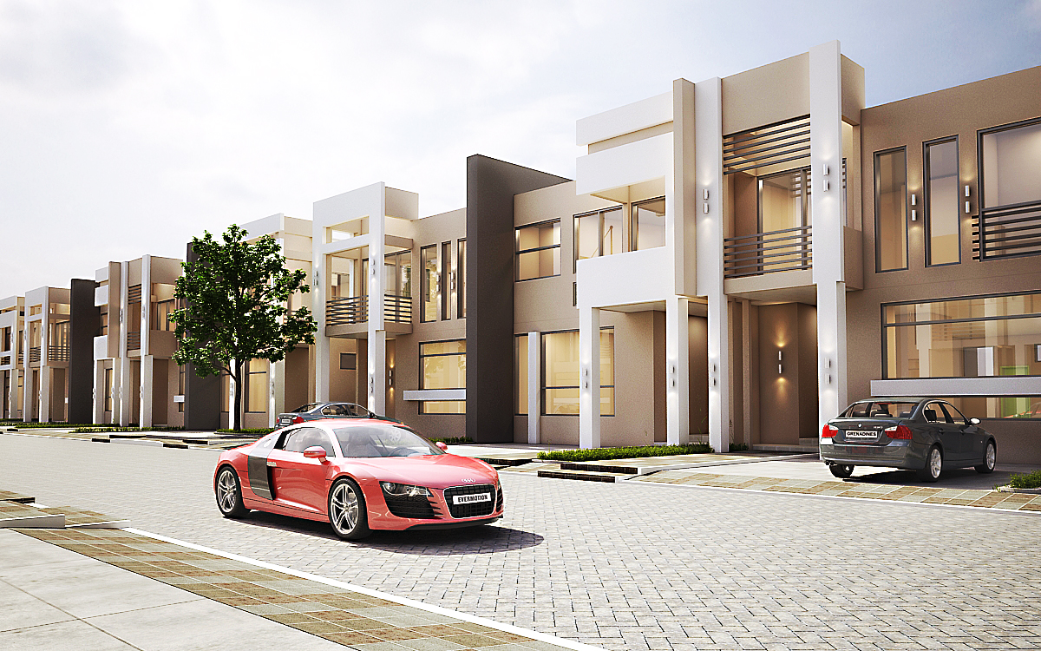
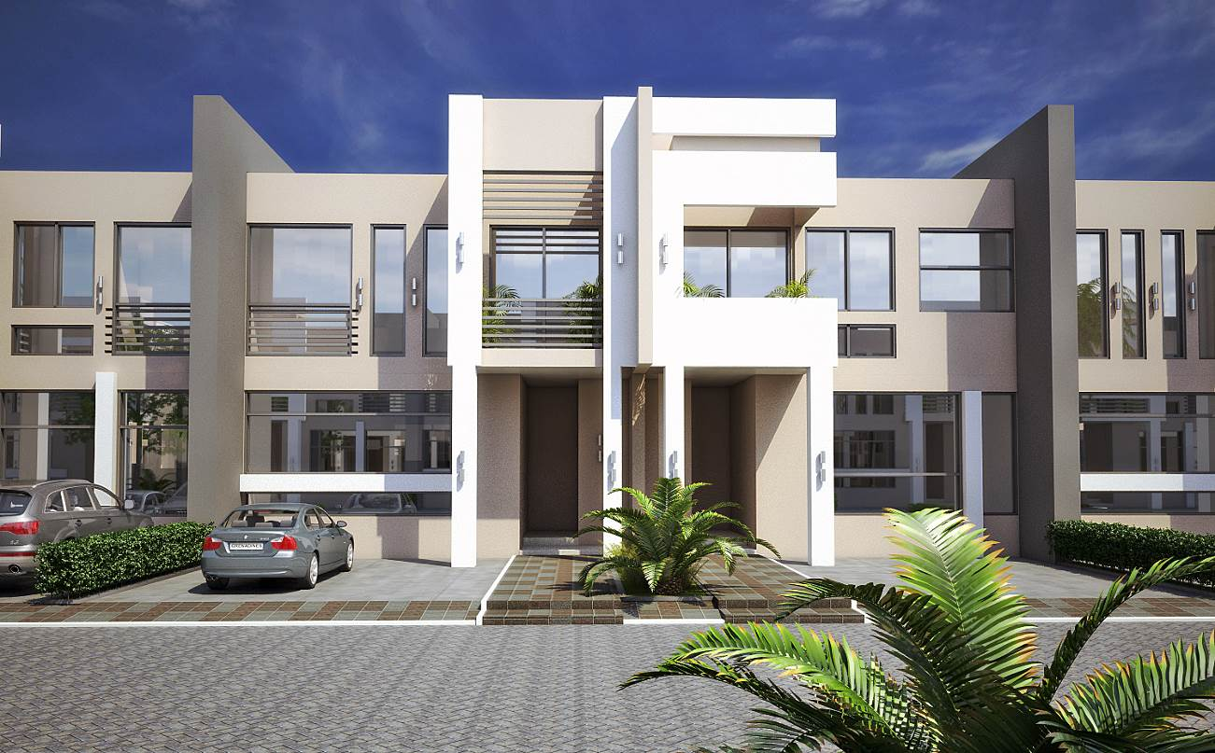
The Front View of The Terrace

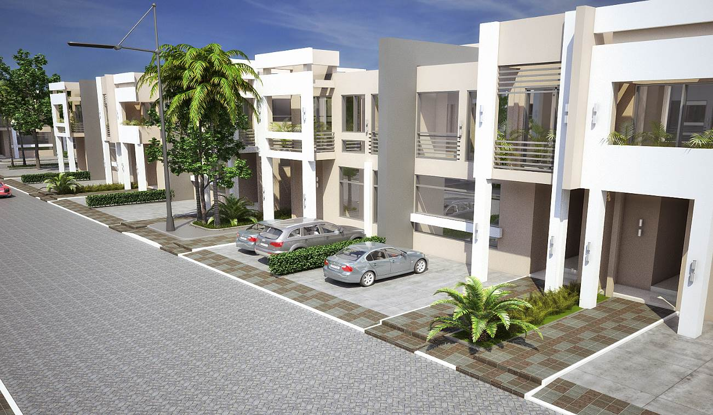
The front view capturing the whole block

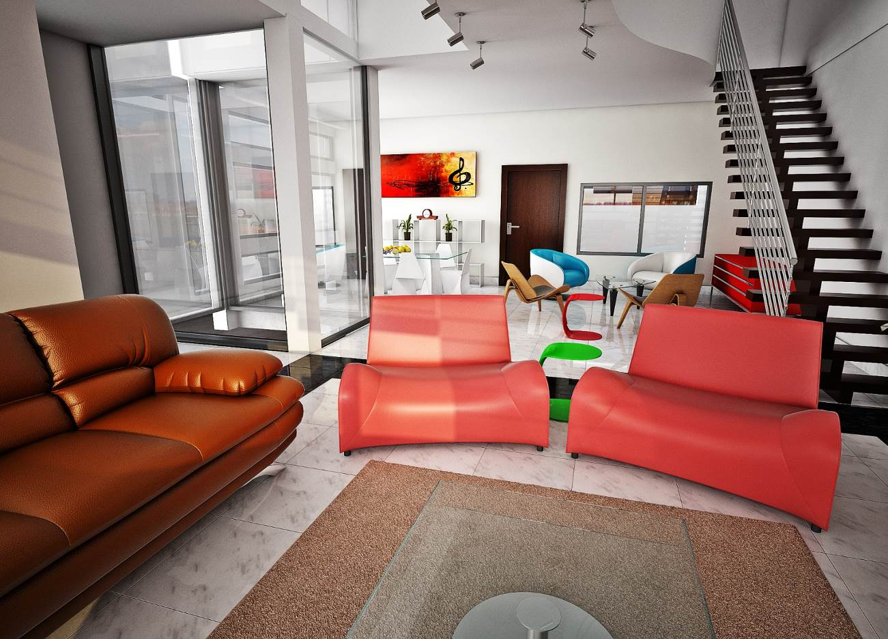
The living room showing the atrium + 2nd Living room + Kitchen and Dinning space.

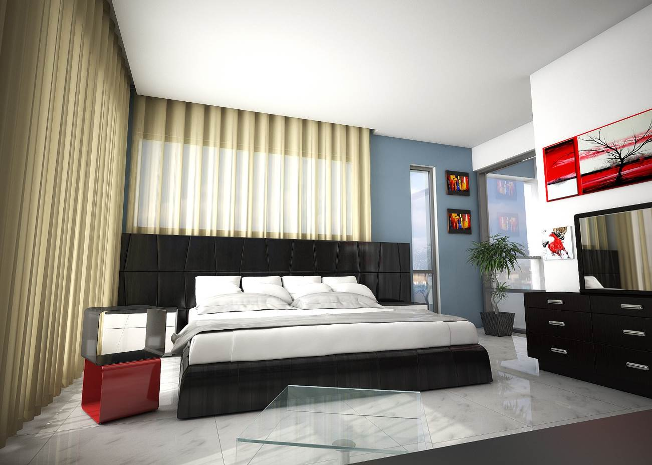
One of the bedrooms

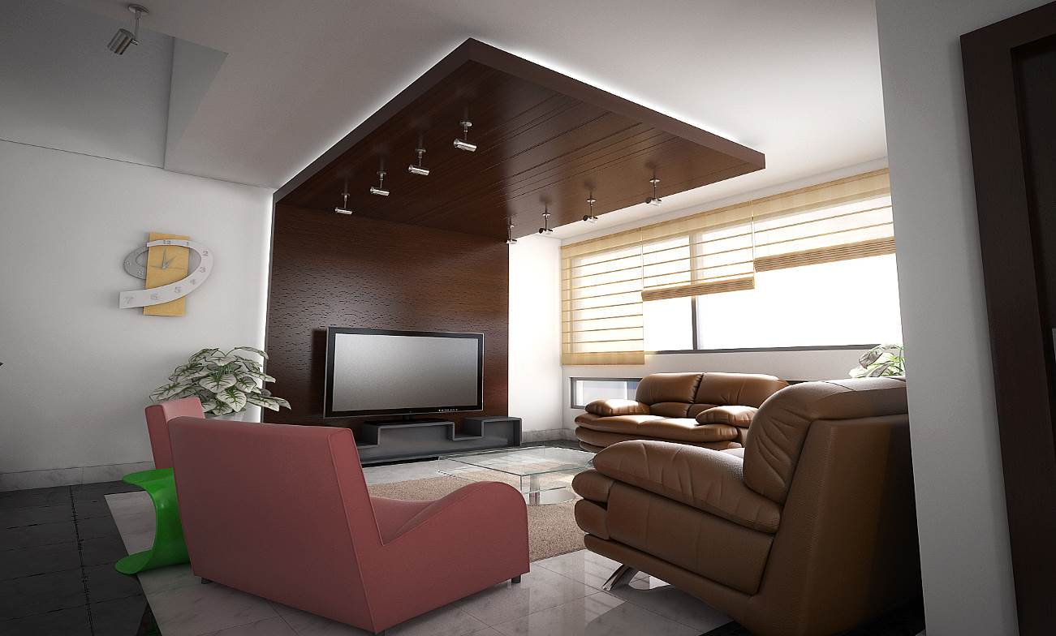
One of the rooms

FLOOR PLAN
Ground floor
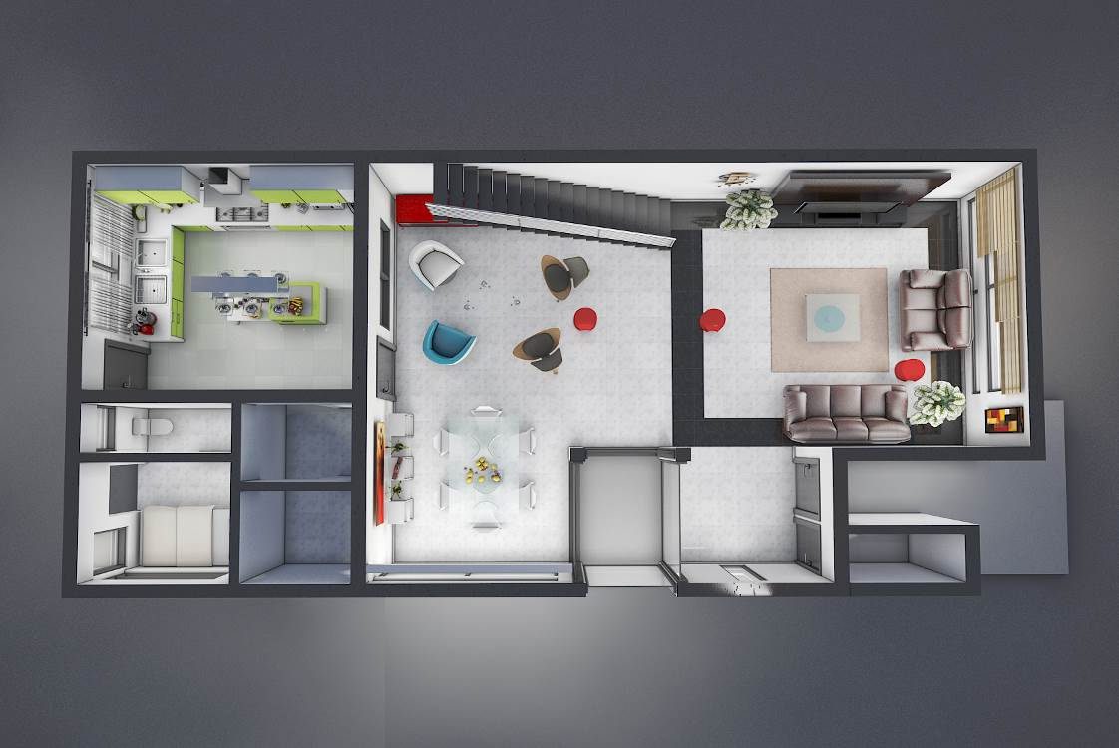

First floor
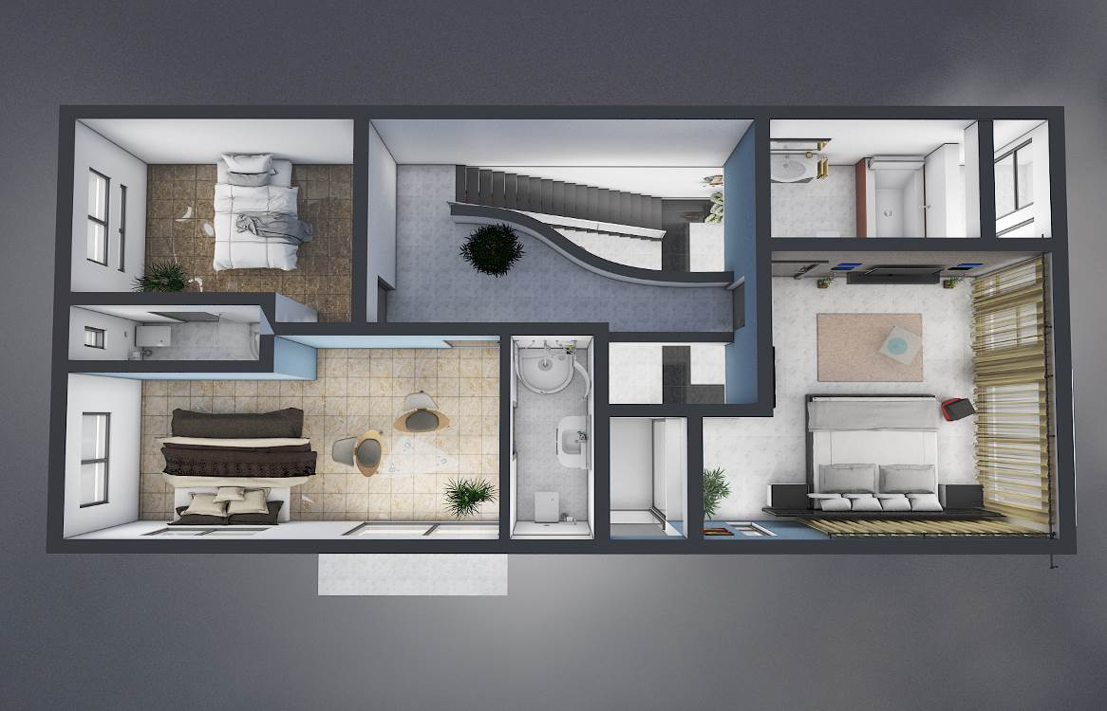

Prices for the 4 bedroom Terrace are stated below:
PAYMENT PLAN FOR CUSTOM BUILT TERRACE
PAYMENT PLAN | PRICE | INITIAL DEPOSIT
Outright Payment | N27,350,000 | 100%
3 months plan | N29,166,600 | 40%
6 months plan | N29,683,300 | 30%
9 months plan | N30,200,000 | 20%
12 months plan | N30,716,000 | 15%
15 months plan | N31,233,300 | 10%
18 months plan | N31,750,000 | 5%

Details of custom built Terrace:

Finishes to be done by Propertymart | - Exterior of building will be completed  - Aluminium windows fixed  - Pipe works done  - Building will be roofed  - Glass windows fixed  - Building will be plastered  - Entrance and exit doors fixed  - Electric cables fixed  - Staircase with hand rails
Finishes not to be done by Propertymart | - Sanitary wares, taps etc  - Burglary proof on the windows  - P.O.P Ceilings  - Inner doors  - Tiles and floor finishing  - Electrical fitting  - Kitchen cabinets etc  - Tiles, interior painting and other interior works  - Joinery works on staircase

4 unit terrace covers - 422.sqm
Area of each Terrace ( footage) - 105.4sqm

